Ideation Phase
Define the Problem Statements

Date
Team ID
Project Name
Maximum Marks

Customer Problem Statement Template:
Retail store managers need an effective way to determine where products should be placed to attract customers and maximize sales. However, they often rely on manual analysis and experience instead of data-driven insights. This results in poor product visibility, inefficient inventory management, and reduced profitability. Strategic Product Placement Analysis addresses this problem by analyzing sales data, customer purchasing behavior, and product performance to recommend optimal product placement strategies.
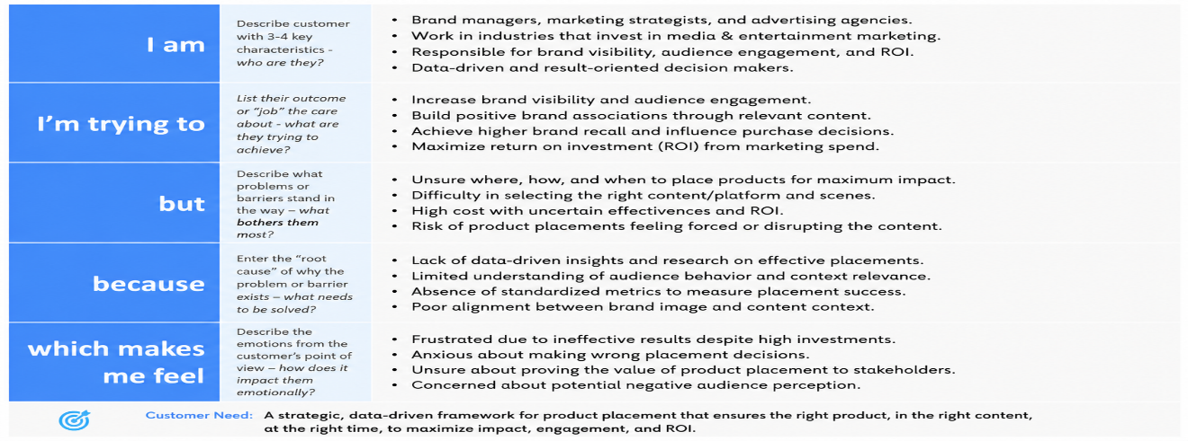
Reference: https://miro.com/templates/customer-problem-statement/
Example:
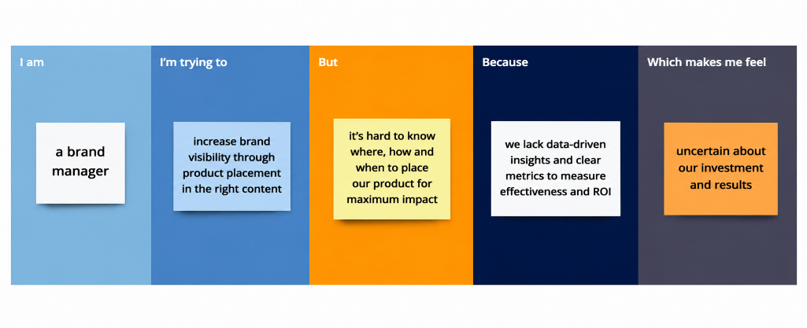

Problem Statement (PS) | I am (Customer) | I’m trying to | But | Because | Which makes me feel
PS-1
PS-2

